CS5542 Big Data Apps and Analytics

LAB ASSIGNMENT #2

1. R Project

A dataset was prepared and k-means clustering operation was performed. The number of clusters used for this specific dataset would be 5. The dataset consists the reaction time during sleep and the respective dataset comprises of Reaction, Days and Subject.

The following screenshots can be previewed:

1. Location of sleepstudy.csv

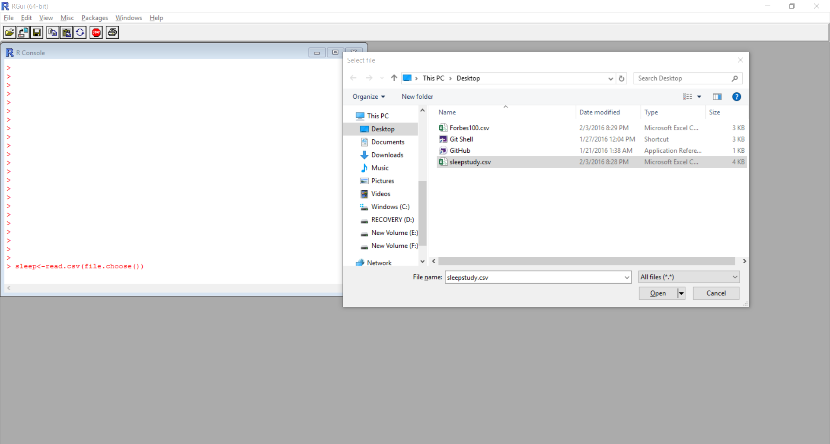

1. K-means clustering operation

The kmeans function in R was used and this brought about the following plot graph, where the number of clusters is 5.

